# JS Apps Exam – Airline-Administration Application

You are assigned to implement a **Web application** (SPA) using HTML5, JavaScript, AJAX, REST and JSON with cloud-based backend (Kinvey). The **app** that keeps **users** (airline administrators) that manage **flights**. Users can **register**, **login**, **logout**, view a page with **all public** flights, **create** a flight, **edit** and **delete** their own flights, view a **detailed** page of a flight and view their **own** flights only.

You are **allowed** to use libraries like **jQuery**, **Handlebars** and **Sammy**. Frameworks and libraries like React, Angluar, Vue are **not permitted**.

## Create a Kinvey REST Service

Register at **Kinvey.com** and create an application to keep your data in the cloud.

Create a collection **flights**. Each flight has a **destionantion** airport, **origin** airport, **departure time**, number of **seats** in flight, **cost** per seat, flight **image**, and information whether the flight **is** **public** or not.

## Test the Kinvey REST Services

### Common Responses

**Note:** When creating or updating records, the response will contain the **entire record** body, as it appears in the database. It’s advisable if you observe network traffic via Postman or using your browser’s dev-tools, to view details about each request.

|  |  |
| --- | --- |
| **Response Code** | **Response Body** |
| 200 OK | *<Record data>* |
| 201 Created | *<Record data>* |
| 204 No Content | *<Empty>* |
| 401 Unauthorized | {  "error": "InvalidCredentials",  "description": "Invalid credentials. …",  "debug": ""  } |
| 404 Not Found | {  "error": "EntityNotFound",  "description": "This entity not found in the collection",  "debug": ""  } |
| Error response  409 Conflict | {  "error": "UserAlreadyExists",  "description": "This username is already taken. …",  "debug": ""  } |

Using **Postman** or other HTTP client tool (you can use Kinvey’s built-in **API Console**), test the REST service endpoints:

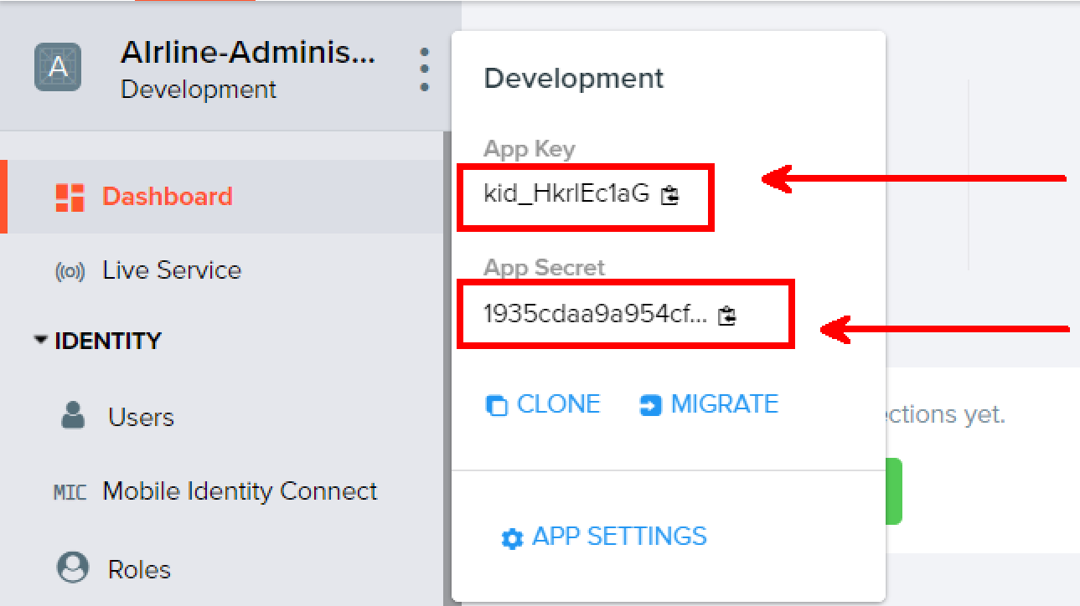

### User Registration (Sign Up)

|  |  |
| --- | --- |
| **POST** https://baas.kinvey.com/user/***app_key***/ | |
| Request headers | Authorization: Basic base64(app_id:app_secret)  Content-Type: application/json |
| Request body | {  "username": "testuser",  "password": "testuserpass890"  } |

The request needs “**Basic**” authentication. Use the Kinvey **App Key** and Kinvey **App Secret** as credentials.

### User Login

|  |  |
| --- | --- |
| **POST** https://baas.kinvey.com/user/***app_key***/login | |
| Request headers | Authorization: Basic base64(app_id:app_secret)  Content-Type: application/json |
| Request body | {  "username": "testuser",  "password": "testuserpass890"  } |

Successful login returns an “**authtoken**” which is later used to authenticate the CRUD operations.

### User Logout

|  |  |
| --- | --- |
| **POST** https://baas.kinvey.com/user/***app_key***/_logout | |
| Request headers | Authorization: Kinvey **authtoken** |

To logout, you need to provide the “**authtoken**” given by login / register as “**Kinvey**” authorization header.

### Get Published Flights

|  |  |
| --- | --- |
| **GET** https://baas.kinvey.com/appdata/app_key/flights?query={"isPublished":"**true**"} | |
| Request headers | Authorization: Kinvey authtoken |

### Create Flight

|  |  |
| --- | --- |
| **POST** https://baas.kinvey.com/appdata/***app_key***/flights | |
| Request headers | Authorization: Kinvey authtoken  Content-Type: application/json |
| Request body | {  "destination":"Las Vegas",  "origin":"New York",  "departure":"2017-02-02",  "seats":25,  "cost":15,  "image":"http://air.....jpg ",  "isPublished": true  } |
|  |  |

### Edit Flight

|  |  |
| --- | --- |
| **PUT** https://baas.kinvey.com/appdata/**app_key**/flights/**flight_id** | |
| Request headers | Authorization: Kinvey authtoken  Content-Type: application/json |
| Request body | {  "destination":"Las Vegas",  "origin":"New York",  "departure":"2017-02-02",  "seats":25,  "cost":15,  "image":"http://air.....jpg ",  "isPublished": true  } |

### Delete Flight

|  |  |
| --- | --- |
| **DELETE** https://baas.kinvey.com/appdata/***app_key***/flights/***flight_id*** | |
| Request headers | Authorization: Kinvey authtoken |

### Flight Details

|  |  |
| --- | --- |
| **GET** https://baas.kinvey.com/appdata/**app_key**/flights/**flight_id** | |
| Request headers | Authorization: Kinvey authtoken |

### My Flights

|  |  |
| --- | --- |
| **GET** https://baas.kinvey.com/appdata/app_key/**flights**?query={"_acl.creator":"**user_id**"} | |
| Request headers | Authorization: Kinvey authtoken |

Use the ID of the currently **logged in user**.

## HTML and CSS

You аre given the Web design of the application as **HTML** + **CSS** files.

* Initially all views and forms are shown by the HTML. Your application may **hide** by CSS (display: none) or **delete** from the DOM all unneeded elements or just display the views it needs to display.
* You may render the views / forms / components with **jQuery** or **Handlebars**.

**Important**: don’t change the elements’ **class name** and **id**. Don’t rename form fields / link names / ids. You are **allowed** to add **data attributes** to any elements. You may modify **href attributes** of links and add **action/method attributes** to forms, to allow the use of a routing library.

## Client-Side Web Application

**Design** and **implement** a client-side front-end app (SPA). Implement the functionality described below.

### Notifications (10 pts)

The application should notify the users about the result of their actions.

* In case of successful action an **informational (green) notification message** should be shown, which disappears automatically after 3 seconds or manually when the user clicks it.



* In case of **error**, an **error notification message (red)** should be shown which disappears on user click.



* During the AJAX calls a **loading notification message (blue)** should be shown. It should disappear automatically as soon as the AJAX call is completed.



***Points for notifications are awarded separately for each section.***

### Navigation System (10 pts)

Implement a **navigation system** for the app: navigation links should correctly change the current screen (view).

* Clicking on the links in the **menu** or **individual** links should display the view behind the link (views are sections in the HTML code).
* The given „**Navigation**“ menu should be visible **only** for logged in users. Anonymous users can **only** view the **login/register** section and logged in users can view **flights** section.

### Register User Screen (5 pts)

By given **username**, **password and repeat password** the app should register a new user in the system.

* After a **successful registration**, a notification message “User registration successful.” should be displayed and the user should be **redirected** to the home view.
* You **need** to validate the **input**. A username **should** be a string with at **least** 5 characters **long**. Passwords **input** fields shouldn’t be **empty**. Both passwords **should** match.
* In case of **error** (eg. invalid username/password), an appropriate error **message** should be displayed and the user should be able to **try** to register again.
* Keep the user session data in the browser’s **session storage**.
* Clear **all** input fields after **successful** register.



### Login User Screen (5 pts)

By given **username** and **password** the app should be able to login an existing user.

* After a **successful login**, a notification message “Login successful.” should be displayed and and the user should be **redirected** to the home view.
* In case of **error**, an appropriate error message should be displayed and the user should be able to fill the login form again.
* **Form validation** should be the **same** as register.
* Keep the user session data in the browser’s **session storage**.
* Clear **all** input fields after **successful** login.



### Logout (5 pts)

Successfully logged in user should be able to **logout** from the app.

* After a **successful** logout, a **notification** message “Logout successful.” should be displayed.
* After successful logout, the **Sign In screen** should be shown.
* The **“logout” REST service** at the back-end should be obligatory called at logout.
* All local information in the browser (**user session data**) about the current user should be deleted.

### Home Screen (List all published flights) (20 points)

Whenever the user opens the home screen a list of all published flights (public flights by all users) should be shown in the following format:

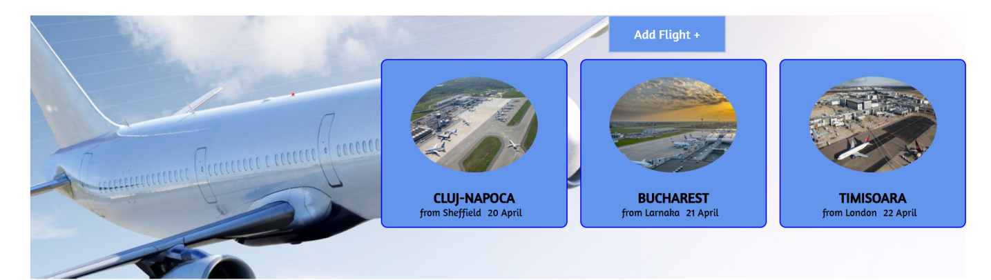

### Add Flight (10 points)

Clicking on **[Add Flight+]** button should **redirect** to form where the admin creates a flight.

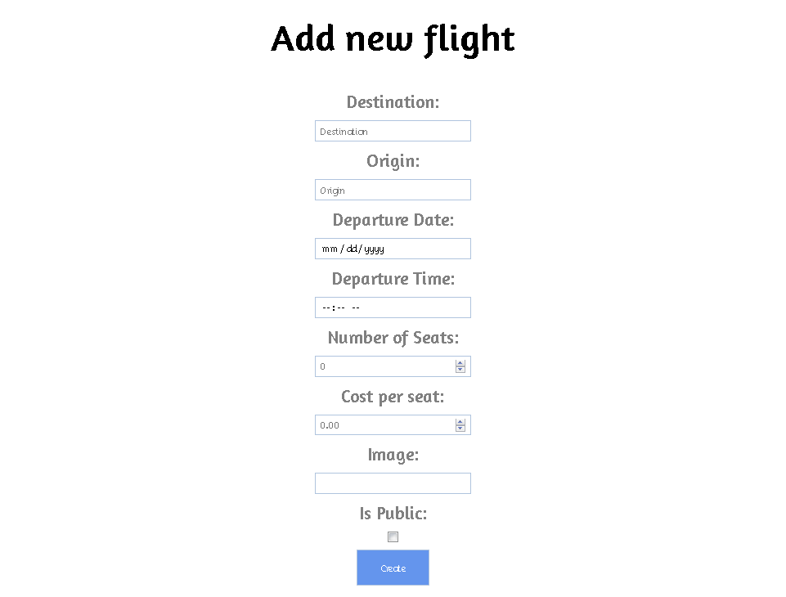

Each flight has a **destination** station, **origin** station (both strings), a **departure** time, number of **seats** per flight, **cost** per seat (both should be validated that they are valid numbers) an image **url** and information whether the flight is **public** or not. Destination and origin station should be **non-empty** strings. Number of seats and cost per seat should be **positive** numbers. (after successful creation of a flight redirect to the home screen and display a message “Created flight.”)

### Flight Details (10 points)

Clicking on each **individual** flight on the home screen or My Flights, **redirects** to a flight details page where **additional** information for each flight is shown (departure hour, departure minutes, number of seats, cost per seat). If the user is the creator of a flight, display the option to edit it (pencil icon).

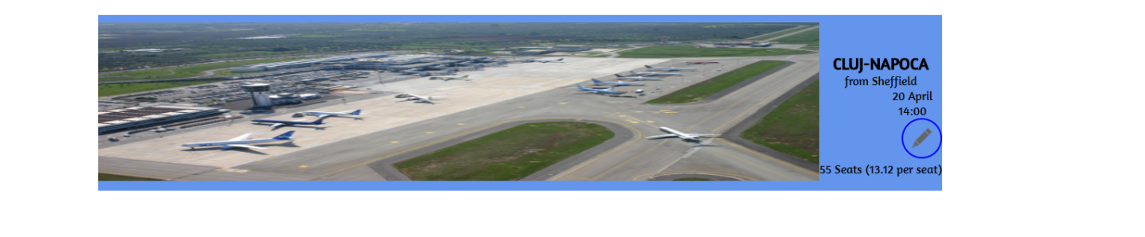

### Edit flight (10 points)

If the user is the **creator** of a specific flight he should be able to **edit** it. Clicking on the edit button **redirects** to a form where the user can **modify** the given flight (all validations in **create a flight** should be followed).

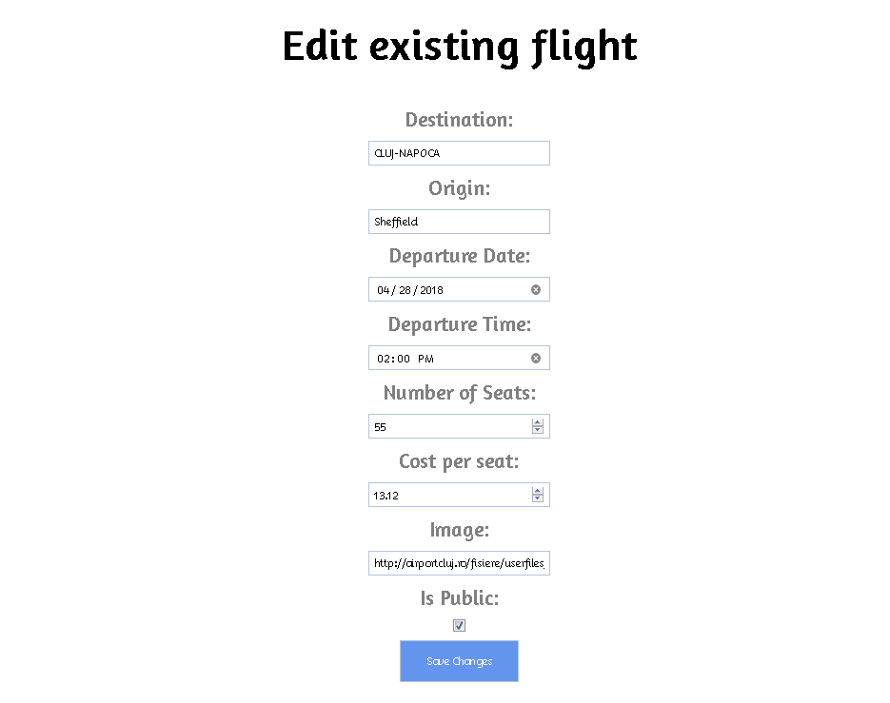

After **successfully** editing a flight the user should be **redirected** to the **details** page of the flight a message “Successfully edited flight.” should be shown.

### My Flights (10 points)

All **authenticated** users can view their **own** flights by clicking on the **[Flights]** button in the navigation.

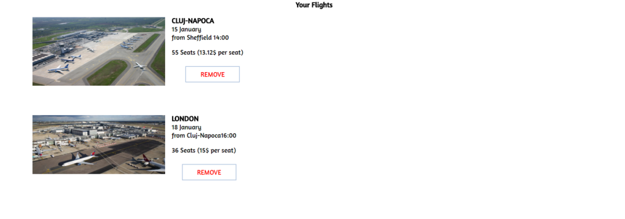

### Delete Flight (5 points)

In the **My Flights** section users can **delete** their **own** flights. Deleting is done **instantly**. When the user **successfully** deletes a flight the message “Flight deleted.” should be shown and the user should be **redirected** to the **same** page.

## Subtmitting Your Solution

Place in a ZIP file your project folder. Exclude the node_modules folder. Upload the archive to the Judge.